Modeling Geo-Influence of Politicians using Twitter

Talha Oz
George Mason University
4400 University Drive
Fairfax, VA 22030 USA
+1-571-201-0575
toz@gmu.edu
Manqi Li
George Mason University
4400 University Drive
Fairfax, VA 22030 USA
+1-703-123-4567
toz@gmu.edu

Arie Croitoru
George Mason University
4400 University Drive
Fairfax, VA 22030 USA
+1-703-123-4567
toz@gmu.edu

ABSTRACT
Political geography, indeed a subfield of electoral geography in particular, studies the geographical relationships between the electors and the elected. In this study, we propose a novel method to model the geographical influence of politicians using location information of their Twitter followers and retweeters. To the best of our knowledge, this study is the first to examine the politician influence geography by means of a social media platform.
Twitter has become a popular data source for electoral studies and utilized in many different ways including predicting election results [9, 12, 14] and classifying political orientation of users [4, 6]. Early studies regarding to political orientation of public (which naturally directly effects the election predictions) later received serious criticism regarding to their evaluation of prediction success. There are others who studied the adoption of Twitter and its usage patterns by the members of the Congress [2, 10, 11].
Location information in Twitter data has also been exploited by researchers for geospatial analysis purposes. Takhteyev et al. studied the influence of geographic distance on the formation of social ties on Twitter [13], Conover et al. examined the geographic patterns of communication networks of a social movement [5], and Croitoru et al. introduced a system prototype for collecting geographical information from social media [7].
Finally, we should note that measuring influence on Twitter is another important research area related to our study. Cha et al. [3] discussed three measures of influence, i.e. indegree (follower), retweet and mention, across different topics and time span. They found that mention and retweet influence measures are highly correlated as they are about engagement while they found popularity (indegree) unrelated to engagement (both retweet and mention measures). They also showed that most of the influential users hold significant influence over a variety of topics, and it’s the news agencies who are retweeted, and the celebrities who are mentioned the most. Bakshy et al. on the other hand approached the problem from an word-of-mouth diffusion perspective and investigated who and what causes the large cascades [1].
In this study, we introduce a geospatial model on how to measure, quantify and visualize the influence of politicians on geographical regions using social media. Our case study is the U.S governors. There are several reasons for selecting governors over other potential politician groups such as congresspeople:
- Twitter rate limiting slows down the data collection speed, so collecting follower and retweeter information of 50 people (i.e. governors) as opposed to 100 (i.e., senators) or 435 (i.e., number of representatives) will shorten the data collection time. See Figure 1 for a comparison of follower counts of governors and senators.

Permission to make digital or hard copies of all or part of this work for personal or classroom use is granted without fee provided that copies are not made or distributed for profit or commercial advantage and that copies bear this notice and the full citation on the first page. To copy otherwise, or republish, to post on servers or to redistribute to lists, requires prior specific permission and/or a fee.
PolNet 8th, May 1–2, 2015, Portland, OR, USA.
Copyright 2010 ACM 1-58113-000-0/00/0010 …$15.00.

- All the 50 governors have at least one Twitter account (unlike the members of the House of Representatives) and their Twitter accounts are publicly available.
- We can further study the relationship between governors’ county level vote share in the last elections and their geographical influence on Twitter.

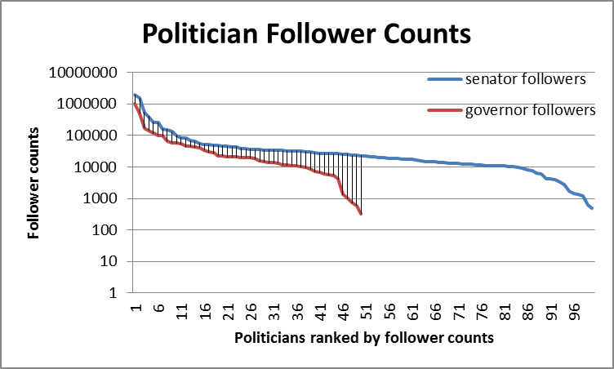
Figure 1 Twitter follower counts of U.S governors and senators
We first get the location information of followers and retweeters of a governor at city level using Twitter’s followers/ids and users/lookup APIs (we can make use of some software libraries for alias resolution at this point, such as Carmen [8]), and then using census dataset we aggregate them at county level. Finally, we normalize these counts by the population of the counties and create their choropleth maps.
The source code of this project is made publicly available and the county level the interactive geo-Influence intensity map created by using Google Fusion Tables is also accessible online at talhaoz.com/geoInfluence.

Keywords
Twitter, politics, geography, influence, congress.

ACKNOWLEDGMENTS
Our thanks to ACM SIGCHI for allowing us to modify templates they had developed.

REFERENCES

[1] Bakshy, E., Hofman, J.M., Mason, W.A. and Watts, D.J. 2011. Everyone’s an Influencer: Quantifying Influence on Twitter. Proceedings of the Fourth ACM International Conference on Web Search and Data Mining (New York, NY, USA, 2011), 65–74.
[2] Bramlett, J. 2014. The tweeting of the U.S. Senate: Content analyses of usage, messaging, and strategies by U.S. Senators on Twitter. Arkansas State University.
[3] Cha, M., Haddadi, H., Benevenuto, F. and Gummadi, P.K. 2010. Measuring User Influence in Twitter: The Million Follower Fallacy. ICWSM. 10, 10-17 (2010), 30.
[4] Cohen, R. and Ruths, D. 2013. Classifying Political Orientation on Twitter: It’s Not Easy! Seventh International AAAI Conference on Weblogs and Social Media (2013).
[5] Conover, M.D., Davis, C., Ferrara, E., McKelvey, K., Menczer, F. and Flammini, A. 2013. The Geospatial Characteristics of a Social Movement Communication Network. PLoS ONE. 8, 3 (Mar. 2013), 1–8.
[6] Conover, M., Ratkiewicz, J., Francisco, M., Gonçalves, B., Menczer, F. and Flammini, A. 2011. Political polarization on twitter. ICWSM (2011).
[7] Croitoru, A., Crooks, A., Radzikowski, J. and Stefanidis, A. 2013. Geosocial gauge: a system prototype for knowledge discovery from social media. International Journal of Geographical Information Science. 27, 12 (Dec. 2013), 2483–2508.
[8] Dredze, M., Paul, M.J., Bergsma, S. and Tran, H. 2013. Carmen: A twitter geolocation system with applications to public health. (2013).
[9] Gayo-Avello, D. 2012. “ I Wanted to Predict Elections with Twitter and all I got was this Lousy Paper”–A Balanced Survey on Election Prediction using Twitter Data. arXiv preprint arXiv:1204.6441. (2012).
[10] Golbeck, J., Grimes, J.M. and Rogers, A. 2010. Twitter use by the U.S. Congress. Journal of the American Society for Information Science and Technology. 61, 8 (Aug. 2010), 1612–1621.
[11] Lassen, D.S. and Brown, A.R. 2010. Twitter: The Electoral Connection? Social Science Computer Review. (Sep. 2010), 0894439310382749.
[12] Metaxas, P.T., Mustafaraj, E. and Gayo-Avello, D. 2011. How (Not) to Predict Elections. 2011 IEEE Third International Conference on Privacy, Security, Risk and Trust (PASSAT) and 2011 IEEE Third Inernational Conference on Social Computing (SocialCom) (Oct. 2011), 165–171.
[13] Takhteyev, Y., Gruzd, A. and Wellman, B. 2012. Geography of Twitter networks. Social Networks. 34, 1 (Jan. 2012), 73–81.
[14] Tumasjan, A., Sprenger, T.O., Sandner, P.G. and Welpe, I.M. 2010. Predicting Elections with Twitter: What 140 Characters Reveal about Political Sentiment. ICWSM. 10, (2010), 178–185.

https://twitter.com/gov/lists/us-governors/members
https://github.com/oztalha/News-Commentary-Tweets-of-Elites

